Backup Center private preview

# Vision:

Backup Center is **one dashboard view** for customers to manage backups across all the resources in Azure and hybrid resources backed up to Azure. It encompasses backup information from workloads protected by Azure Backup, Backups taken by First party services and 3rd party Partners, value-added services built by Azure Backup. From Backup Center, customers can set governance rules such as giving the intent to backup resources, track compliance status, monitor the backups and able to restore at an application level or at a resource level or do granular item restore from a resource.

Just like Security Center and Azure Monitor are one-stop shop for all the management operations related to Security and Monitoring respectively, we imagine Backup Center to be the one Dashboard for all the backup related activities.

We are starting the journey with an experience that aggregates the backup information for Azure VMs protected by Azure Backup across recovery services vaults across subscriptions.

# Participate in private preview

To enroll into private preview, please send us list of subscriptions/tenant ID you want to see in Backup center to: [BackupCenterV-team@service.microsoft.com](mailto:BackupCenterV-team@service.microsoft.com).

It will take up to 48 business hours for us to accept the subscriptions and provide access to you.

Please note that this will not in anyway affect your running backups. We collect backup data about your VMs and send it to [Azure Resource Graph](https://azure.microsoft.com/en-in/features/resource-graph/) and run queries on top of it to paint the view. So, it will not affect your backup jobs in anyway and feel free to use it as many subscriptions as you can.

## Pricing:

During private preview, you won’t be charged. We will communicate the pricing change closer to GA.

# Getting Started:

1. Go to aka.ms/backup-center [ This is Azure Portal with Backup Center private preview exp enabled. All other functions of Azure portal work as is].
2. Click on “All Services” from menu.

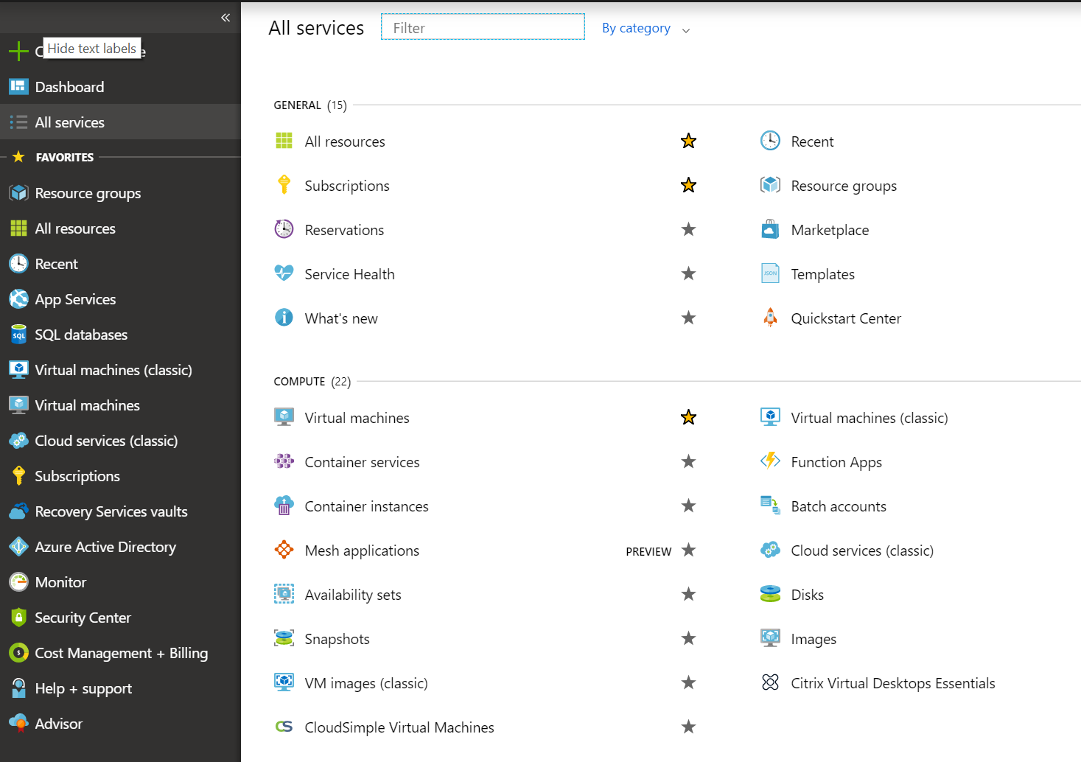

1. Type “Backup Center” in filter box and click on Backup Center result to open the experience.

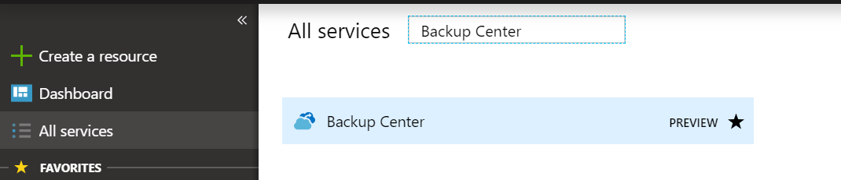

Optionally you can also select the star mark to pin to left hand menu.

1. This will open Backup Center experience which contains two sections:
2. Governance view
3. Monitoring view.

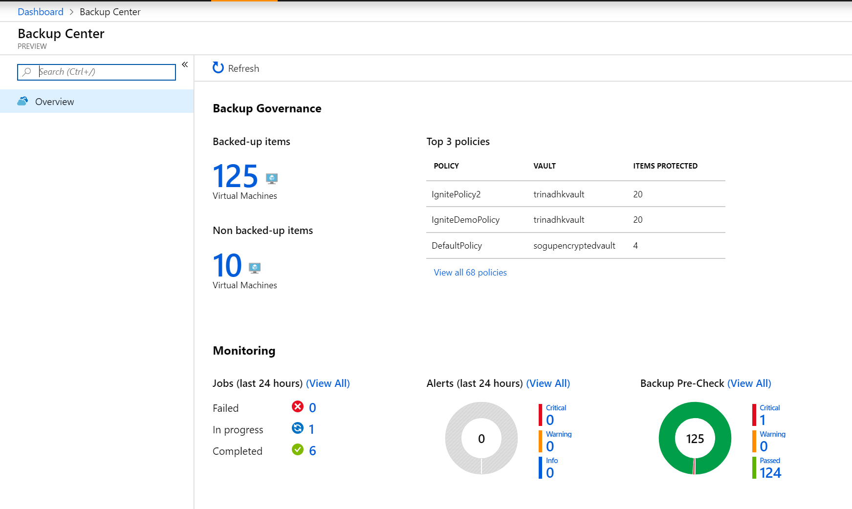

1. If you want to change the set of subscriptions for which this experience is shown, please select them from subscription filter on top right of the Azure portal. Please make sure that you select subscriptions which are only part of subscriptions which are accepted for private preview.

# Governance view:

This view is aimed at answering two important questions:

1. Am I protecting all the resources which need to be protected?
2. Am I protecting my resources with right set of policies as per my compliance requirements?

First question is answered by set of views: backed-up items and non-backed-up items. Second question is answered by list of policies and in the dashboard you will top policies (in terms of maximum number of resources they protecting) which are being used to protect.

## Backed-up items

You can drill down into back-up items to view list of backup items across vaults and subscriptions and clicking on each of the line item you will be able to perform the actions such as : on-demand backup, restoring VM, restoring files and stopping protection for the VM.

## Non backed-up items

To view VMs which are not getting protected:

1. Click on Non-backed up items tile on the Dashbaord.
2. This might take 1-2 minutes for fetch complete list of recommendations and time to load varies based on no of subscriptions selected.

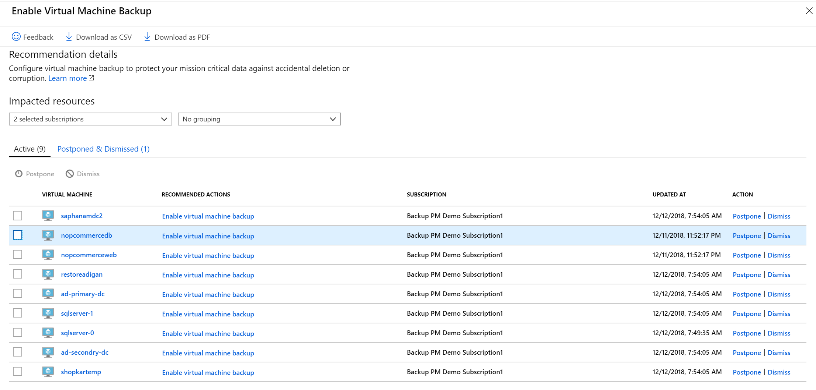

You can select the Virtual Machine to view the Overview screen of the VM or directly click on “Enable virtual machine backup” recommendation to bring Configure Backup screen. You have the option of Postpone and Dismiss for these recommendations.

## Policies

To view set of policies being used in your subscriptions, click on “View all policies “ link in “Top 3 Policies” tile from dashboard. This will bring list of policies and clicking on the row will show the policy information.

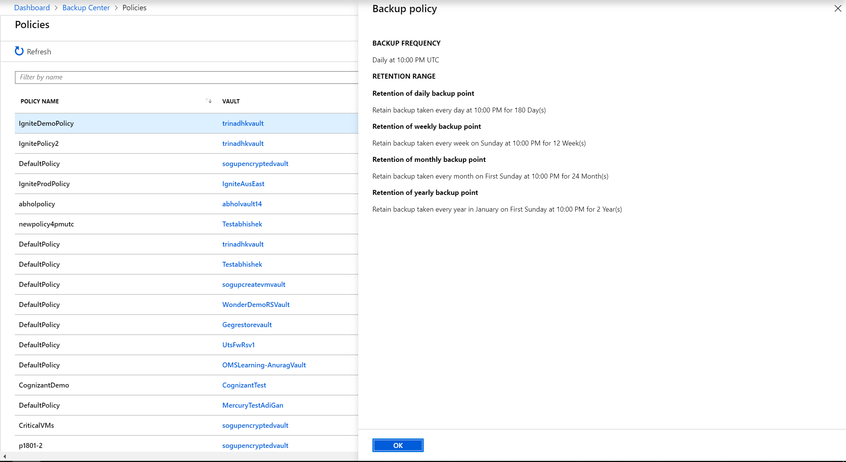

You can optionally click on Vault and go to specific policy from vault and be bale to modify or view set of items this policy is protecting.

# Monitoring

Monitoring view is divided into two aspects:

1. Proactive monitoring via Backup precheck
2. Reactive monitoring via Jobs and Alerts

## Jobs:

By default, Backup Center will show jobs triggered in last 24 hours. It will have jobs categorized to success, failed and warning. By clicking on “View All” from Jobs tile, you can go to all jobs view and change filters to see jobs from the past.

## Alerts:

Backup Center dashboard will show active alerts triggered in last 24 hours. They are categorized into critical, warning and info.

Please note that dashboard view will not capture all active alerts from the past. It will only show active alerts triggered in last 24 hours. To view all active alerts, click on “View All”, and change the time range and status filters to see all active alerts.

## Backup precheck:

In dynamic environment, configuration drift on resources can have impact on scheduled backups. Backup precheck helps you understand what are the issues which can prevent you from having successful backups. You can click on individual categories to understand issues and take corrective action.